From Awana.org and Awana Force websites:
The new Awana Leader Award System recognizes leaders who seek out ministry training and honors those who desire to serve the Lord with excellence! As an Awana leader you can document the number of RIUs (or leader training credits) you have earned using Training Tracker. Training Tracker is a Web-based administrative tool that allows you to record all the training and ministry experience you’ve completed. Watch your total number of RIUs grow with each entry and display RIU pins on your leader lanyard!
Get Started A course list, achievement-level information can be found on the Training Tracker coarse catalog.
- Scroll through the course catalog, select a course you have done.
- Review the course description, requirements, click New Training Tracker Credit to record credit in your transcript.
- Completed the required fields and click save!
- View your transcript or your profile to view the RIUs you have earned!
Your commander can view your transcript through their own ART account and can present your awards right along with the clubbers. You can display those achievements with the correct color lanyard and RIU pins on your name card.
There are over 100 ways to earn RIUs. They’re all listed in the Training Tracker course catalog. Check out a few of the ways to earn RIUs! You may have already earned some! Already completed Basic Training?
You've earned five RIUs. Once you have your total, you’ll be ready to wear: New name card, lanyard, RIU pins

http://awana.force.com which is the ART (Awana Resources and Tools) page (which needs a login setup) Training Tracker tab has your account info and a way to add the training credits as above call RIU units.
1.) What’s your color?
Lanyard color to signify a new level of achievement.
Based on the number of RIUs you have earned, you'll be entitled to wear the black, bronze, silver, gold or platinum lanyard.
2.) What’s your certification?
Display your BT certification pertaining to your role in club.
3.) What's your number?
Display the number of Rorheim Institute Units (RIUs) you've earned on your lanyard name card. Start with Basic Training and go from there. There are more than 100 ways to earn RIUs.
Questions- email Ministry Services MinServ@awana.org

 | Achievement Level
 | Bronze | 60 RIUs
 | Silver | 120 RIUs
 | Gold | 180 RIUs
 | Platinum | 240 RIUs

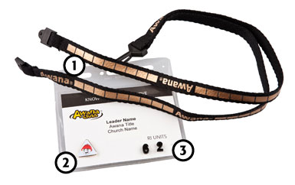

T&T Club Leaders Resources Page https://c.na3.visual.force.com/apex/default56

